|  |  |
| --- | --- |
| Student name Mohan Kumar Neerakallu | |
| Student ID 19493389 | |
| Course code | **COMP710** |
| Course Title | **Web Application Development** |
| Tutor name | **Sue Beale** |
| Assignment | **1 – Investigation & Implementation Research Project** |
| Due Date | **Week 8** |
| Date Submitted 03-09-2020 | |
| Case Study JavaScript – HTML5 Canvas game development | |

This assignment is my own work:

Your name: _______Mohan Kumar Ramalingaiah Neerakallu__________

Case Study: ____ **JavaScript – HTML5 Canvas game development**

**Introduction:**

* JavaScript programming language is used to create web applications, mobile apps, desktop applications, backend servers, and databases.
* JavaScript can be used to develop games. Both 2d and 3d libraries can be used along with JavaScript to create games in the browser or any other game engine platforms.
* However, the majority of JavaScript game development focuses on creating games for the browser.

**Scenario of the game:**

* I have created a simple game using JavaScript and HTML5.
* Boxes with specific pixels are created and the box moves in different directions to collect the item and the more times it collects, the boxes will be incremented.
* Keyboard arrow keys are used to move the box in four directions. Each key has a code and based on this code functions are used in JavaScript to move the box in the game.
* Game over and collision scenarios are created with JavaScript functions. This is like a snake game which collects food.

**Game Screenshot:**

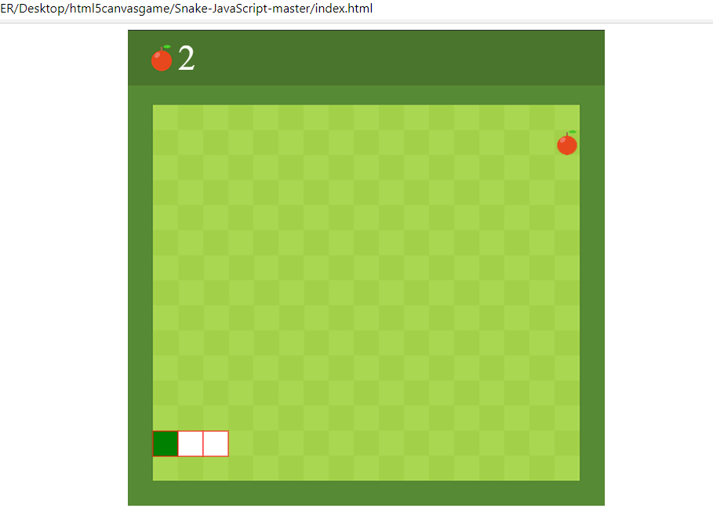**Coding Screenshots:** 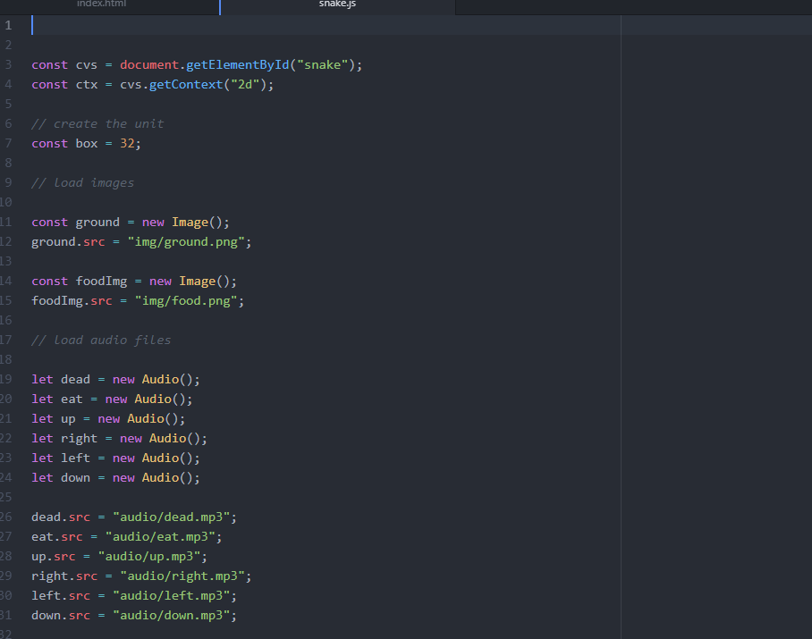

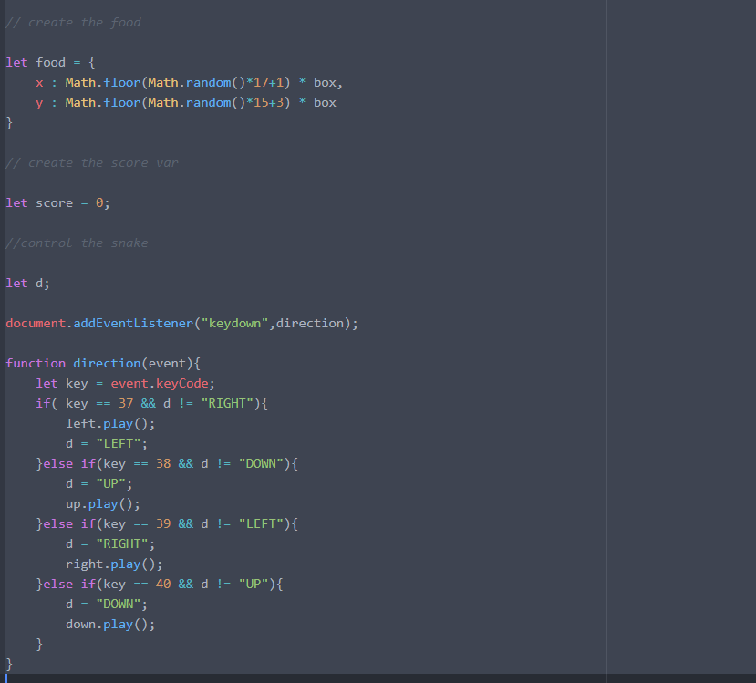

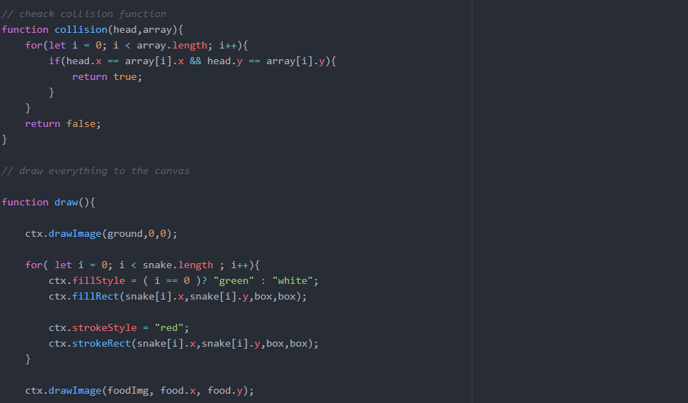

All the above screenshots show the coding for creating the box, loading image, audio files, collision feature and drawing of boxes in different directions using JavaScript programming language. (Explained, 2018)

**Advantages of JavaScript and HTML5 canvas gaming:**

* Speed - JavaScript tends to be very fast.
* Simplicity- JavaScript's syntax was inspired by Java and is relatively easy to learn.
* Best for creating games on browsers. (Dunne, 2019)
* JavaScript can be used to build Hybrid mobile apps with frameworks like WebView Mobile Development Framework.
* HTML5 games can be accessed on a variety of devices like phones, PCs, laptops, and other smart devices with web browsers, so this cross-platform functionality can be considered as an advantage.
* HTML5 games are easier to maintain and update. New updates to the game are configured automatically and users don’t need to update the software themselves. Once the updates are made, they’re applied to all platforms where users can play the latest version of the game.

**Disadvantages of JavaScript and HTML5 canvas gaming:**

* JavaScript is not preferred for developing games with high graphics.
* Additional frameworks are required to develop games for mobile platforms.
* HTML5 requires modern browsers to access it.

**Recommendation:**

* Considering the advantages and disadvantages, I would like to recommend the JavaScript game development with HTML5 for developing games which does not require high graphics. It is not suitable for console game development.
* We can consider it developing Hybrid Apps, which is helpful for the developers if they do not have clear knowledge about specific mobile programming language like Java.

# References

Dunne, G. (2019, November 28). *Jsdairies*. Retrieved from Jsdairies: https://www.jsdiaries.com/can-javascript-be-used-to-make-games/

Explained, C. (2018, August 08). *codeexplained.org*. Retrieved from codeexplained.org: https://www.codeexplained.org/2018/08/create-snake-game-using-javascript.html